Laboratory Study
Student’s Name
Institution
Date

Laboratory study
Lab 8: Seasons, Solstices, and Equinoxes
Hypothesis 1
1
Moving closer to the fire by an amount above 1.7% ensures one feels warmer than before because there is an increased radiation rate. The closer one gets towards the fire, the high amount of radiation that gets received.
2
During January, the earth is at the tropic of cancer, making the sun's effects to get felt till June as it moves to the equator. The movement of the sun towards the equator makes the poles cold.
Hypothesis 2
1
There is a difference between the model sun to the southern and northern hemisphere when a tilt gets done. Tilting the northern hemisphere towards the sun makes it warmer than the southern hemisphere that is away from the sun. When the southern hemisphere is tilted towards the sun, it becomes warmer than the northern hemisphere.
2
The events of the northern and southern hemispheres tilting towards and from the sun are the main reasons for different seasons on the earth. The parts that face the sun tend to become warmer while the others become cold.
Hypothesis 3
1
As the revolves and rotates around the sun, the Northern Hemisphere received summer when it tilted towards the sun, while the Southern Hemisphere receives winter because it doesn't face the sun.
Video breaks down
2
The earth does not get the same amount of light daylight regardless of the latitude. The side that faces the sun during the tilt receives more daylight than other areas. Some other parts not facing the sun receive total darkness.
3
Both the northern and southern hemispheres receive an equal amount of daylight.
A
The North Pole receives both day and night.
B
The South Pole receives partial day and night.
4
Northern and southern hemispheres do not receive an equal amount of daylight. The southern hemisphere receives longer days.
5
The earth's axis towards the sun makes the northern hemisphere face the sun and become warm.
6
The length of the day gets affected by the seasons that get received on earth. Tilting of the northern hemisphere towards the sun leads to creating a warmer season as the South Pole becomes cold.
Hypothesis 4
1
a. Summer
b. Winter
2
The light looks brighter in summer and fainter in winter.
3
Earth receives more energy in the summer because direct sun rays hit it perpendicularly.
4
Tilting of earth towards the sun leads to the creation of seasons because of the sun's reduced intensity on some areas leading to cold.
Lab 9: The Moon, Revisited
Part I: Interpreting our Observations of the Moon
1
I observed eight lunar phases that include waxing crescent, new moon, first quarter, waxing gibbous, full moon, waning gibbous, last quarter, and waning crescent.
2
The distance was about 50 kilometers, with the moon not at the zenith but getting close at the earth's overhead.
3
We located the direction of the moon somewhere at the western horizon. The time was about 9 p.m. when such observation got made in the universe.
4
I could not cover the moon with the tip of my hand because it was near the earth with giant body size. The moon was the first quarter and was near the earth.
Lunar phase | Range of dates observed
New moon | 14 December
Waxing crescent | 22 December
First quarter | 1st December
Waxing gibbous | 27th December
Full moon | 30th December
Third quarter | 8th December
Waning crescent | 11th December
5
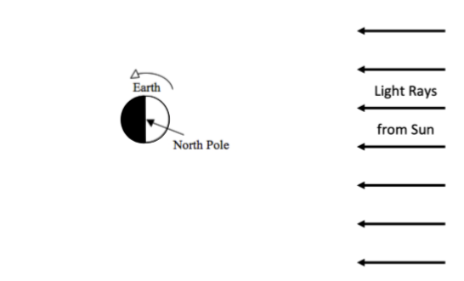
First Quarter
1st Dec

Full moon 30th Dec
New Moon 14th Dec
Third Quarter
8st Dec
6
I used the dates that the moons appear in the different months to ensure that the date's right estimate gets determined. 30 + 1 + 14 +8 = 53.
7
A maximum of 31 days is in one month; therefore, 53 – 31 leads to the creation of 22 days.
Part ii: The Clockwork Moon
1
Phase | Rise time | Highest in sky | Set time
New | 3 a.m. | 9 p.m. | 3 p.m.
First quarter | 3 a.m. | 9 p.m. | 3 a.m.
Full | 3 a.m. | 9 a.m. | 3 p.m.
Third quarter | 3 p.m. | 9 p.m. | 3 a.m.

2
Phase | Rise time | Highest in sky | Set time
Waxing crescent | 3 p.m. | 9 p.m. | 3 p.m.
Waxing gibbous | 3 a.m. | 9 p.m. | 3 a.m.
Waning gibbous | 3 a.m. | 9 a.m. | 3 p.m.
Waning crescent | 3 p.m. | 9 p.m. | 3 a.m.
3
The time makes sense because they are more or less in the same period of making observations. For instance, seeing the waxing crescent rise at 3 p.m. got done by many students.
4
The time would be after midnight, most likely at 3 a.m.
Part iii
1
The moon is tidally locked because of the change of its orbit.
2
24 hours and 50 minutes
3
The moon contains a dark side
4
Yes
5
Waning gibbous
6
Yes
7
The moon takes the time to complete one spin on its axis take long. The movement of the moon on its axis takes one year.

